VOICE FOR SALESFORCE
BY ENREACH
Use Cases & Functionality
Voice for Salesforce Web phone
Version 1.48

Contents
1 Introduction 3
1.1 Pre-requisities 3
1.2 Login to the solution 3
1.2.1 Login 3
1.2.2 Availability management 6
1.3 Omni-Channel Availability integration 6
1.3.1 Omni-Channel login 7
1.3.2 Omni-Channel Availability management 8
1.4 Voice for Salesforce web phone 9
2 Phone workflows 10
2.1 Case - phone workflow 10
2.1.1 Inbound call – Single identified customer 10
2.1.2 Inbound Call – Not identified / Multiple identified customers 11
2.1.3 Outbound call – Single identified customer 12
2.1.4 Outbound call – Not identified / Multiple identified customers 12
2.2 CaseDialog - phone workflow 12
2.2.1 Inbound call – Not identified customer 12
2.2.2 Inbound call – Single identified customer 13
2.2.3 Inbound call – Multiple identified customers 14
2.2.4 Outbound calls 15
2.3 Contact&Account – phone workflow 15
2.3.1 Inbound call – Not identified customer 16
2.3.2 Inbound call – Single identified caller 16
2.3.3 Inbound call – Multiple identified customers 16
2.3.4 Outbound calls 17
2.4 Contact&Lead – phone workflow 17
3 Call Task Activities and details in Salesforce 18
3.1 Call details 18
3.2 Additional information 19
4 CallBack integration and handling in Salesforce 19
5 Dynamic Smart Routing based on any Salesforce data 21
6 Enterprise Calls 22
7 Enreach cloud management – general use cases 23
7.1 Voice service pool management 23
7.1.1 Voice Center Web UI 23
7.1.2 Voice for iOS and Android mobile app 25
7.2 Dashboards and Reporting 26
7.2.1 Real-time monitoring dashboard 26
7.2.2 Reporting 28

Introduction
The purpose of the document is to describe use cases and functionalities of the Voice for Salesforce by Enreach (later Voice for Salesforce) solution.
The document covers softphone use cases for Voice for Browser web phone. If using Voice for Windows softphone, login and softphone usage is different than described in this document.
Benemen is now Enreach and BeneVoice for Salesforce product is now rebranded as Voice for Salesforce by Enreach starting from version 1.48 .

Pre-requisities
- Customer’s Salesforce org and needed Lightning apps are activated for Voice for Salesforce usage
- End user is activated for Enreach cloud for Salesforce both Salesforce org and Enreach cloud
- End user’s Enreach cloud user role must include Voice for Salesforce web phone usage in order to use workstation based phone use cases
- Embedded Voice for Salesforce web phone in Salesforce is supported using Chrome web browser

Login to the solution

Login
- User logins as normal to Salesforce web user interface
- User opens Salesforce lightning app, where also Voice for Salesforce is activated.
- Voice for Salesforce web phone utility item is visible in the bottom utility bar. It’s recommended that admin has enabled automatic start of Voice for Salesforce utility item. This means that Voice for Salesforce webphone activates and logins automatically. (If admin has not enabled automatic start, then user needs to open Voice for Salesforce web phone, when user is automatically signed in to the web phone.)
- Voice for Salesforce web phone is used for controlling phone calls, managing voice channel availability status and caller phone numbers
Note: If user is using Salesforce Omni-Channel and availability integration with Voice for Salesforce, then availability status is centrally managed via Salesforce Omni-Channel utility item. Please see 1.3 Omni-Channel Availability integration

Important notes:
- Voice for Salesforce web phone shall be used in a single Salesforce browser view / tab, where new views and pages are opened within the same single browser view / tab. Console app is recommended for the best user experience.
- Avoid refreshing the whole browser view / tab. Instead, if you need refresh information on the active page, use built in Salesforce options doing so. This ensures that Voice for Salesforce web phone continues functioning as normal.
- If you refresh the whole browser view / tab, you must then re-login to Voice for Salesforce web phone by opening it. Active phone call is also disconnected if you refresh the whole browser view / tab.
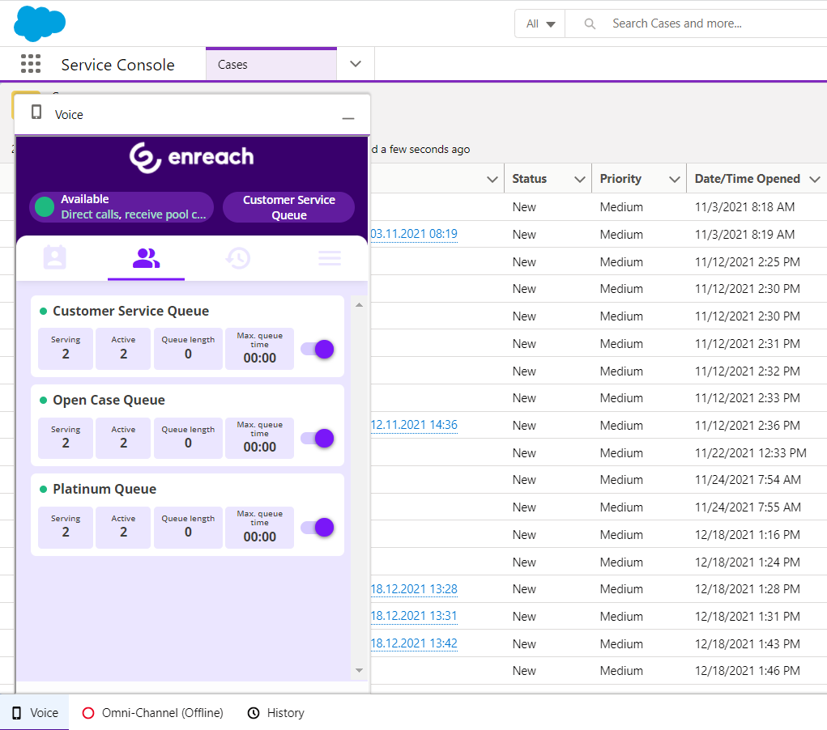
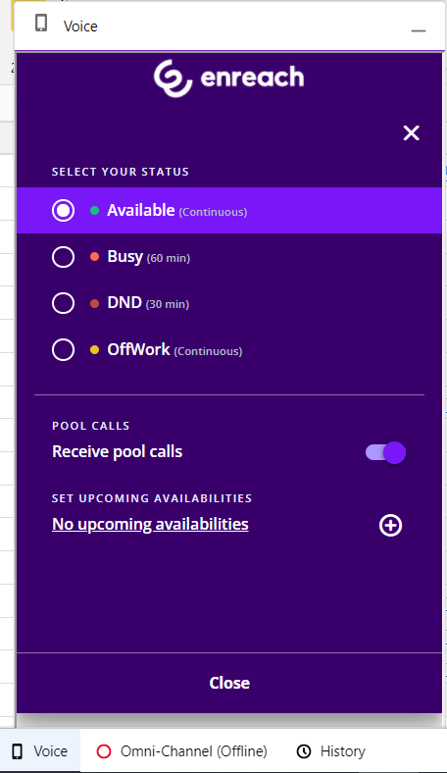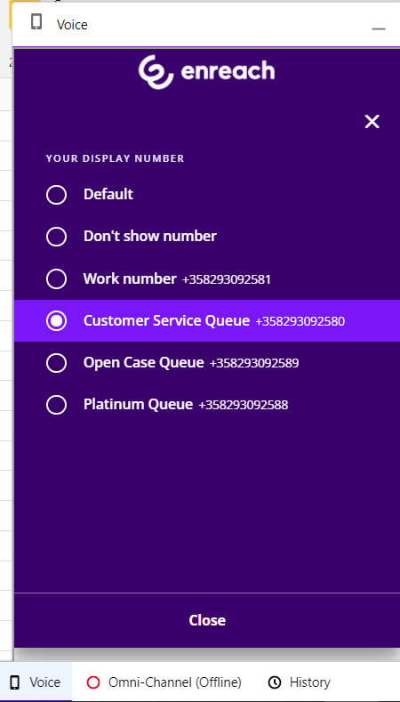

Availability management
Enreach cloud voice service typically includes customer specific availability statuses, but they always follow the status types described in this chapter. User controls available statutes via Voice for Salesforce web phone. Depending on Enreach cloud user role, user may additionally be able to control availability on different voice channel service pools.
- Offwork
  - Not available to receive voice channel service pool calls
  - Available to receive direct calls (depending on user’s call forwarding settings)
  - Able to make outbound phone calls
- Available
  - Available to receive voice channel service pool calls
  - Available to receive direct calls (depending on user’s call forwarding settings)
  - Able to make outbound phone calls
- DND
  - Not available to receive voice channel service pool calls
  - Not available to receive direct calls (depending on user’s call forwarding settings)
  - Able to make outbound phone calls
- Busy
  - Available to receive voice channel service pool calls
  - Available to receive direct calls (depending on user’s call forwarding settings)
  - Able to make outbound phone calls

Omni-Channel Availability integration
This chapter applies only if Omni-channel Availability Integration is enabled. Then during normal operations user controls login and logout to work including Voice queues via Salesforce Omni-Channel widget. Note: User must also be active in Voice for Salesforce web phone in the same lightning app as Omni-Channel widget.
User logins to Salesforce omni-channel and voice queues via Salesforce Omni-Channel widget.
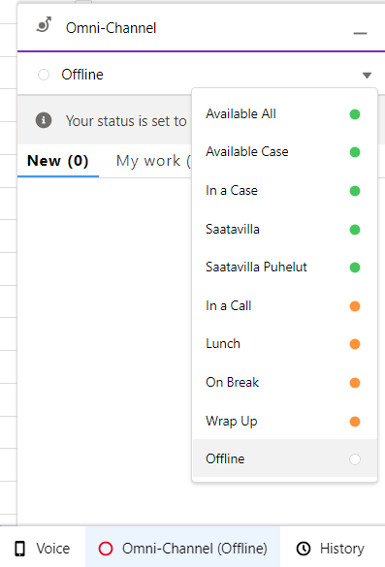

Omni-Channel login
- When user changes status from Offline to any other status, this activates user in the configured voice Enreach cloud voice queues and sets user Enreach cloud status to OffWork or Available. User status mapping is done by Salesforce admin.
- When user changes status from any other status to Offline, this will deactivate user in the configured voice queues and set user Enreach cloud status to OffWork.
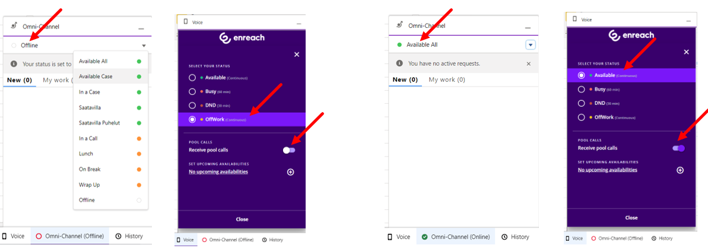

- Going Offline from Enreach cloud voice queues works when user initiates this via Omni-channel widget
- If user goes Offline in Omni-channel by any other reason e.g. closing browser, losing network connection, etc., this will not deactivate user in Enreach cloud voice queues.
- In such a situation user will continue receiving service calls in softphone / configured backup phone terminal, typically mobile device & number. User can then control voice queue activation/deactivation via Enreach UI’s (Voice for Salesforce web phone, Voice for iOS/Android mobile app, Voice Center web ui)

Omni-Channel Availability management
- When working via Salesforce Omni-channel, all status changes are controlled via Omni-Channel widget
- User statuses are mapped by Salesforce admin and updated on the background in real time to Enreach cloud voice channel.
- Examples:
  - If user goes Lunch status in Omni-channel, this will update Lunch offwork status also to Enreach cloud side.
  - User may have certain available type presence statuses for native omni-channel service channels only, e.g. available only for Chat. This can be mapped as Offwork status to Enreach cloud so user will not receive any service calls, but concentrates working only with Chat service channel
  - Simlilarly user may have presence status which makes user available only in voice channel
- For service call handling the integration provides automated “In a Call” and “Wrap Up” handling
  - As soon as phone call is ringing on user web phone or user initiates outbound call, Omni-channel status is automatically changed to “In a Call” and user is busy in omni-channel
  - If the call is answered and then ended, status changes automatically to busy “Wrap Up” status. Wrap Up time is configured by Salesforce admin. User can manually change status from Wrap up to something else before configured maximum time. When configured Wrap Up time ends, status reverts back to original status before the call. Wrap up time is optional e.g. this can be left empty in the configuration if not used.
  - If the call is not answered, there isn’t any wrap up status, but status goes automatically back to the original status
- Additionally integration provides “In a Case” system status to prioritize Omni-Channel service channels and workload over service calls. Salesforce admin can configure numeric workload limit value. If user’s workload is the same or higher than configured value, “in a Case” status is automatically set and user goes Offwork in Enreach cloud side.
- Below screenshot provides example how admin has mapped Salesforce Omni-Channel statuses towards Enreach cloud
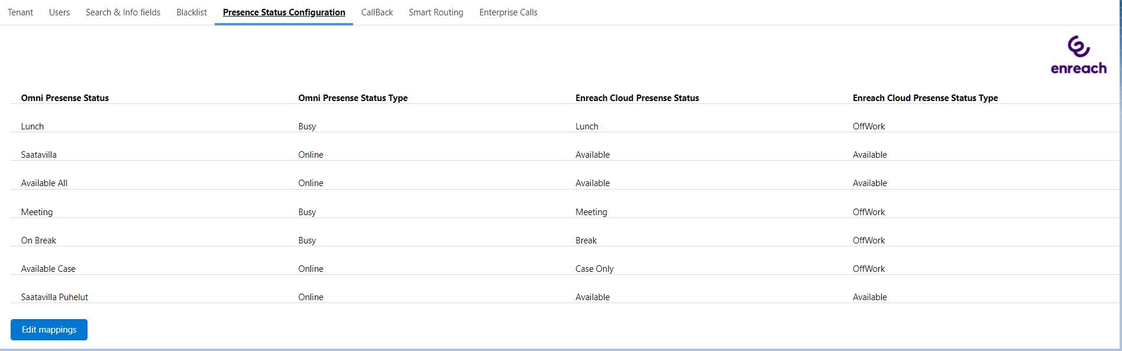

Voice for Salesforce web phone
Web browser based softphone supported in Chrome browser.
General functionality:
- Voice for Salesforce web phone is based on WebRTC technology
- Make phone calls via web phone contact directory, keypad or call history
- Make phone calls via Salesforce view (click-to-dial)
- Answer, end and decline phone calls
- Selecting caller number for outbound phone calls
- Mute / Unmute microphone
- Hold / Unhold phone call
- Call transfer (direct transfer and consulted transfer
- DTMF by keypad
- Caller identification from web phone contact directory and voice channel service pool queue name with receiving phone calls
- Availability status management
- Managing availability in voice channel service pool queues
- Voice channel service pool queue details dashboard
- Call history
- Additional user settings are managed via Voice Center web UI and Voice for iOS and Android mobile apps
More detailed instructions via separate Voice for Browser user guide .
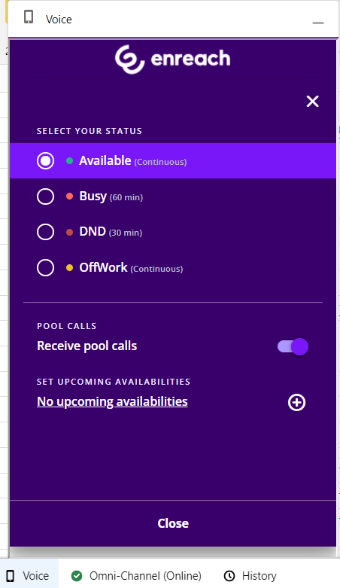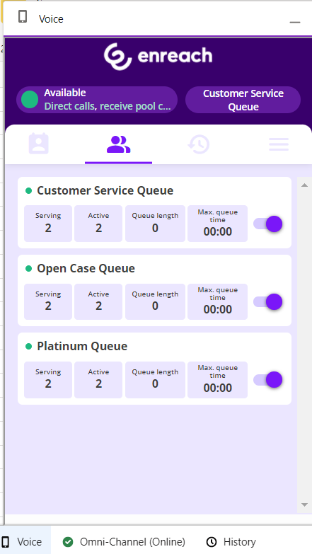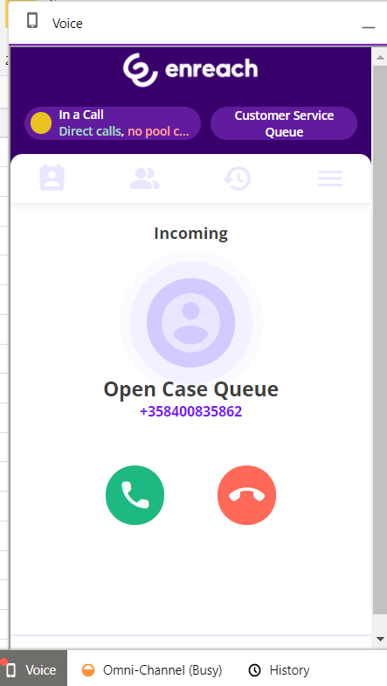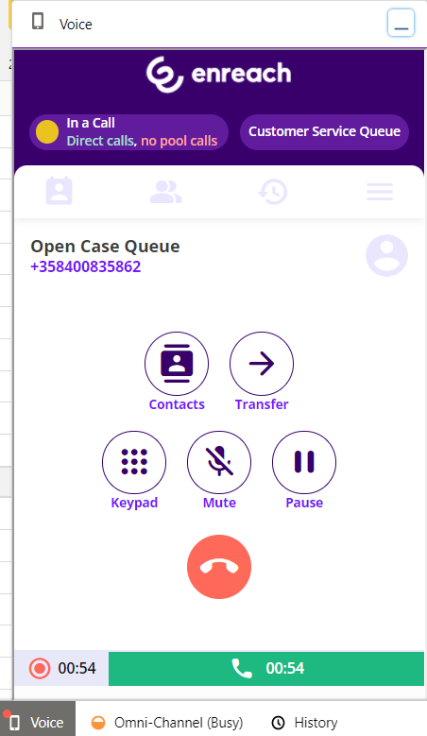

Phone workflows
Choice of 4 different phone workflows, which determine the action with inbound and outbound phone calls. Phone workflow is assigned by admin and can be done on a user basis.
- Case: Automated case creation without contact dialog. Targeted for quick case creation. Requires console navigation type of Lightning app for popping up chosen / new cases.
- CaseDialog: New & Existing Case handling with contact dialog. Targeted for contact identification and case handling. Requires console navigation type of Lightning app for popping up chosen / new cases.
- Contact&Account: Contact & Account identification and screen pop-up.
- Contact&Lead: Contact identification. New Lead handling for not identified contacts.

The following sub-chapters are describing the phone workflows in more detail with all the different call scenarios.
User based phone workflow is configured by admin via Voice for Salesforce configuration app as part of other user specific configuration items.

Case - phone workflow

Inbound call – Single identified customer
- Phone call rings on web phone. Single identified customer 360-view is opened
  - Wephone ui is automatically opened and if service pool queue call, then queue name is visible
  - User answers / decline the call
- When user answers the call, new Case is automatically created and opened. If user declined the call, then a case is not created
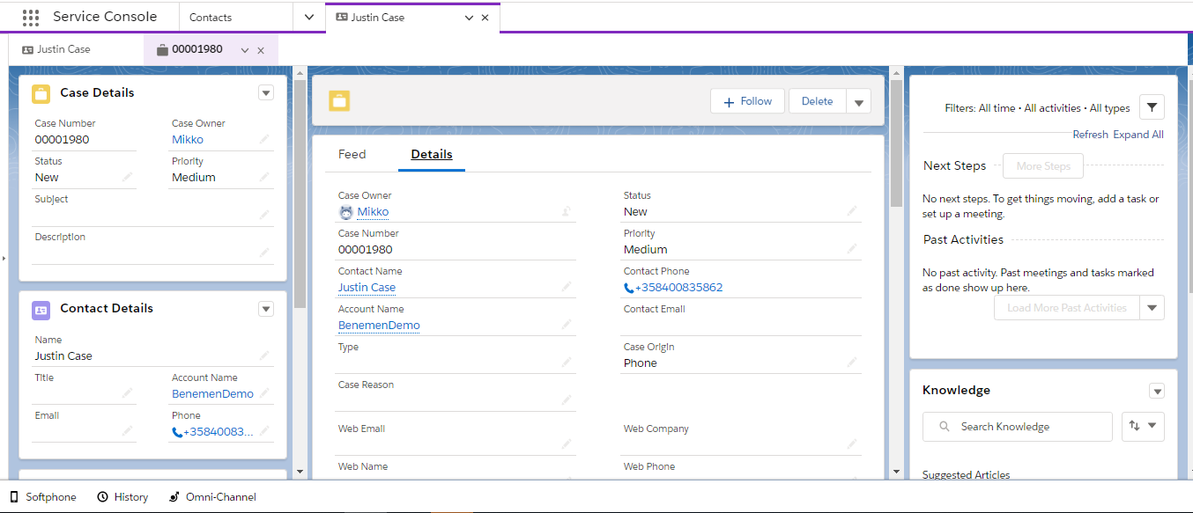
- When the call is ended, call task activity is automatically created in the background and also related to the case and the contact. Note: User configuration includes versatile options when and how call task activities are created and pop-up.
- Advanced call details (queue wait time and link to possible call recording) are autoamtically added to the created call task activity within 10 – 300 seconds after creation.
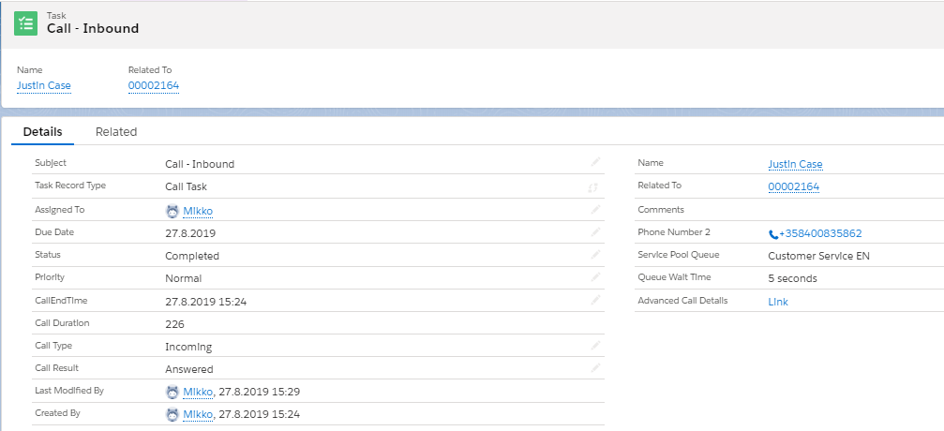

Inbound Call – Not identified / Multiple identified customers
- Web phone rings, no other action is taken
- When user answers the call, new Case is automatically created and opened but without any customer details. If user declined the call, then a case is not created
- Otherwise the same as the previous use case.

Outbound call – Single identified customer
- Click to dial from Salesforce. Ringing tone for called and also visual indicator in a web phone.
- Customer 360-view is opened if the call was initiated from some other view.
- When the customer answers the call, new Case is automatically created and opened. If the customer declined the call, then a case is not created
- Otherwise the same as the previous use case.

Outbound call – Not identified / Multiple identified customers
- The same as with 2.1.2 .

CaseDialog - phone workflow
With inbound phone call, web phone is automatically opened for answer / decline. Additionally service pool queue name is visible if phone call is received by one. Phone call management is done via web phone interface.
Recommended usage model is that call task activities are created in the background automatically and also related to the identified customer and the case without any pop up and user action. Additionally User configuration includes versatile options when and how call task activities are created and pop-up if wanted.

Inbound call – Not identified customer
A phone call rings in a web phone and it’s opened for answer / decline. At the same time separate dialog window is opened to help user to take next actions with the customer.
Dialog window inclde the following:
- Customer phone number and service pool queue name / direct call info
- Option to search existing Contact / Account by name. Additional search variables can be configured by admin.
  - Results will by default show Contact and Account name. Additional result details can be configured by admin. E.g. email address, birthdate, etc.
  - If found, option to automatically update phone number and choose contact
  - Choosing existing contact will take to Single identified customer contact dialog
- Button to create “New Case” without caller identification at this point.
- Close (X) buttons to close dialog without any action.
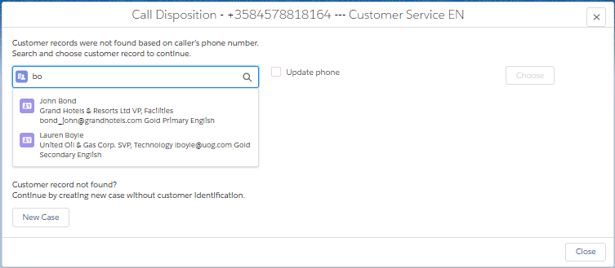

Inbound call – Single identified customer
As soon as call rings on the web phone, the below dialog is opened in Salesforce
- Contact information: Contact name, Account name + additional details configured by admin
- Voice queue name if the call received via queue, otherwise ‘Direct’
- Core details of the five last modified Cases with option to continue working with one. Admin can configure what details are visible.
- Option to search some other existing case for the contact. By default search is by case number, but admin can add additional search variables e.g. Subject.
- Option to create “New Case” for the contact
- Option to create “New Case – Not identified” if you don’t want to use identified user
- Close (X) buttons to close dialog without any action.
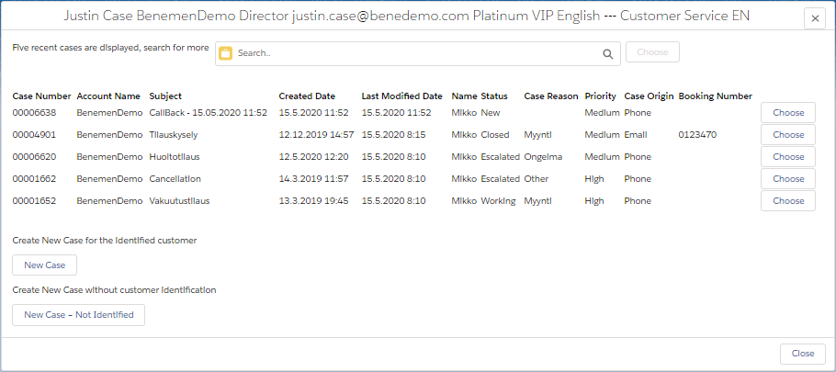

Inbound call – Multiple identified customers
As soon as call rings on the web phone, the below dialog is opened in Salesforce
- On top line caller number and Voice queue name visible. (or Direct if call was not received via queue)
- Lists identified Contacts / Accounts (max 10 of both)
- By default Type, Full Name, Business phone, Account Name and Mobile Phone details are shown. Admin can add additional details to be shown.
- Choosing one will take agent to Single identified dialog
- Search some other contact / account. The same as with Not Identified flow.
- New Case button to create empty case without any contact/account mapping
- Close (X) buttons to close dialog without any action.

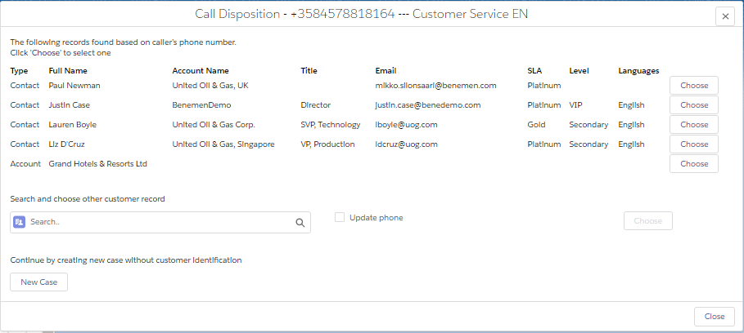

Outbound calls
Currently CaseDialog workflow doesn’t have any specific workflow action for outbound call.
Click-to-dial can be initiated from any phone number type field in any view. (Please consult Enreach if click-to-dial should be available in other data type fields than phone number)
By default Call task activities are created on the background for each outbound call. Call task creation and pop-up can be controlled via user configuration.
If outbound click-to-dial was initiated from Contact object, contact name is automatically assigned in the created call task activity.
If outbound click-to-dial was initiated from some other object, by default automated related to or contact name assignment is not done in the created call task activity. However these can be enabled on tenant and user level configuration.

Contact&Account – phone workflow
With inbound phone call, web phone is automatically opened for answer / decline. Additionally service pool queue name is visible if phone call is received by one. Phone call management is done via web phone interface.

Recommended usage model is that call task activities are created in the background automatically and also related to the identified customer without any pop up and user action. Depending on the use case it might be useful to pop-up activity so that user can add some additional details on it. User configuration includes versatile options when and how call task activities are created and pop-up if wanted.

Inbound call – Not identified customer
As soon as call rings on the web phone , the below dialog is opened in Salesforce.
- Caller number and Voice queue name. (or ‘Direct’ if direct call to agent phone number)
- By default option to search existing Contact / Account by name. Additional search variables can be configured by admin.
  - Results will by default show Contact and Account name. Additional result details can be configured by admin. E.g. email address, birthdate, etc.
  - If found, option to automatically update phone number and choose contact
  - Choosing existing contact will take to Single identified customer contact dialog
- Buttons “New Contact” and “New Account” to create new record. Caller number is automatically included as Phone number.
- Close (X) buttons to close dialog without any action.
- Call Task Activity is created when phone call ends based on used configuration.
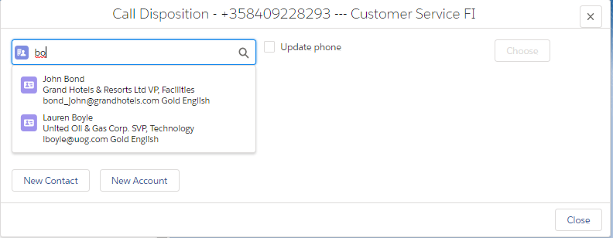

Inbound call – Single identified caller
A phone call rings in the web phone and at the same time customer’s 360-view is opened.
Call Task Activity is created when phone call ends based on used configuration.

Inbound call – Multiple identified customers
As soon as call rings on the web phone, the below dialog is opened in Salesforce
- On top line caller number and Voice queue name visible. (or Direct if call was not received via queue)
- Lists identified Contacts / Accounts (max 10 of both)
- By default Type, Full Name, Account Name details are shown. Admin can add additional details to be shown.
- Choosing one will open given Contact / Account card
- Search some other contact / account. The same as with Not Identified flow.
- Buttons “New Contact” and “New Account” to create new record. Caller number is automatically included as Phone number.
- Close (X) buttons to close dialog without any action.
- Call Task Activity is created when phone call ends based on used configuration.

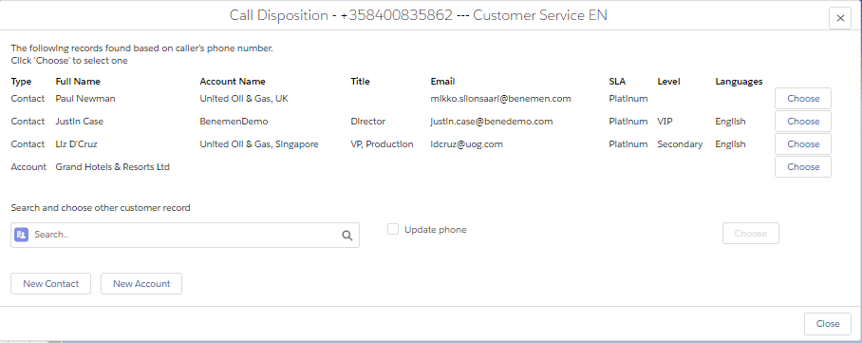

Outbound calls
Currently Contact&Account workflow doesn’t have any specific workflow action for outbound call.
Click-to-dial can be initiated from any phone number type field in any view. (Please consult Enreach if click-to-dial should be available in other data type fields than phone number)
By default Call task activities are created on the background for each outbound call. Call task creation and pop-up can be controlled via user configuration.
If outbound click-to-dial was initiated from Contact object, contact name is automatically assigned in the created call task activity.
If outbound click-to-dial was initiated from some other object, by default automated related to or contact name assignment is not done in the created call task activity. However these can be enabled on tenant and user level configuration.

Contact&Lead – phone workflow
Works the same as with Contact&Account phone workflow, but instead of Accounts it identifies and creates Leads.

Call Task Activities and details in Salesforce
By default call details are automatically saved as call task activities in Salesforce for all the phone calls handled via web phone integration. This occurs when the phone call ends.
Depending on the workflow and caller identification, call task activities are automatically assigned to identified customer and related to worked Case or identified Account. Additionally, for outbound click-to-dial calls related to and contact matching can be automated.
Admin based user configuration provides versatile configuration options ‘when and how’ call task activities are created and pop-up.
Customer may freely modify call task layout including needed fields and details.
Voice for Salesforce provides also an option to automate call task activity creation for ‘any’ Enreach cloud phone call i.e. also for other phone calls than the ones done via Salesforce embedded Voice for Salesforce web phone. Please see Calls Lookup for more details.

Call details
The following call details can be included in the call task activity. Salesforce admin may freely modify the visible fields and also add some customer specific details.
- Call End Time
- Call Duration
- Phone Number 2 (caller number)
- Service Pool Queue (voice queue name)
- Queue Wait Time ( and numeric Queue Wait Time Sec. Added 10 – 300 seconds after activity creation)
- Advanced Call Details (URL to access possible call recording and call details in Enreach cloud side. Added 10 – 300 seconds after activity creation)
- Call Type (incoming / Outbound)
- Call Result (Answered / Not Answered)
- Phone From (Caller number in outbound calls)
- Phone to (used with Enterprise Calls functionality only. Includes Enreach cloud user phone number in the customer phone call)
- Call Date (used with Enterprise Calls functionality only. Timestamp when the customer phone call occured)

Option: Case phone workflow - call details saved within case object

Recommendation is to save call details as Call Task Activity with automated relation to the case. However this admin configuration option can be used for saving call details within worked case object.
Note: All call task activity related configuration options are disabled and not used, when ‘Save Call Info on Case’ option is checked.

Additional information
“Service Pool Queue” and name has central role with Enreach cloud voice queues
- Primary tool / attribute to provide information of the caller, purpose, etc.
- Enreach is not limiting amount of service pools and customer may freely name them
- Visible in call notification, informing agent of the caller, language, purpose, etc.
Wrap Up / After call time details
- Salesforce Omni-Channel and Voice for Salesforce availability integration enables Wrap Up handling fully in Salesforce side
- Wrap Up time is then part of the native Salesforce User Presence dashboards and reports
- Note: If Enreach cloud side on wrap up functionality is used, then this management and reporting happens via Enreach tools and UI’s

CallBack integration and handling in Salesforce
Voice for Salesforce includes option to integrate Enreach cloud callback functionality with Salesforce.
With this integration callback logic and service are implemented as standard service module at Enreach cloud side, but callback requests are fully handled in Salesforce.
- Integration can be activated on Enreach cloud callback list basis. Configuration is described in separate Voice for Salesforce - Configuration guide for admins.
- As soon as customer leaves callback on Enreach cloud side, information is fetched to Salesforce and created as Salesforce Case, Task related to Case or Task only. Timespan for Salesforce record creation is max. ~20 seconds.
- All callback request handling is thereafter happening at Salesforce side. (As soon as callback request is successfully created on Salesforce side, it is automatically closed on Enreach cloud side with ‘Moved to SF’ note.)
- Callback cases are assigned to configured Salesforce queues and customer may assign these to agents by any available method.
- Salesforce Omni-Channel with Voice for Salesforce availability integration could be used here for realtime queueing and routing of callback cases.
- Voice for Salesforce installation creates dedicated callback Case and Task record types and page layouts. Customer may modify these for own needs.
- Contact / Account identification is done based on caller’s phone number.
  - If single Contact / Account is identified, then Case / Task is created for this record.
  - If none or multiple Contact / Account is identified, then Case / Task are created without any assigned Contact / Account record.
- Callback Case / Task subject is: “CallBack - <date & time when callback was left>”
- Callback Case / Task specific fields are
  - CallBack ChannelIn , name of voice queue customer left callback request
  - CallBack CreationTime , original date & time customer left callback request
  - CallBack ContactNumber , phone number to call back to customer
  - CallBack Recording URL , URL to listen callback voice message left by customer
  - Callback Contact message , this can be used for hard coded system message on Enreach cloud side. E.g. if callback cases are created also for missed (abandoned) service calls, this field can include specific hard coded message (i.e. ‘Missed Call’) to separate these from other type of callback cases.
- Standard Voice for Salesforce functionality brings additional value for callback handling as agent’s can use Click-to-dial for outbound calls and automated call task activities are created for the call attempts.

Example of CallBack Case from single identified contact:
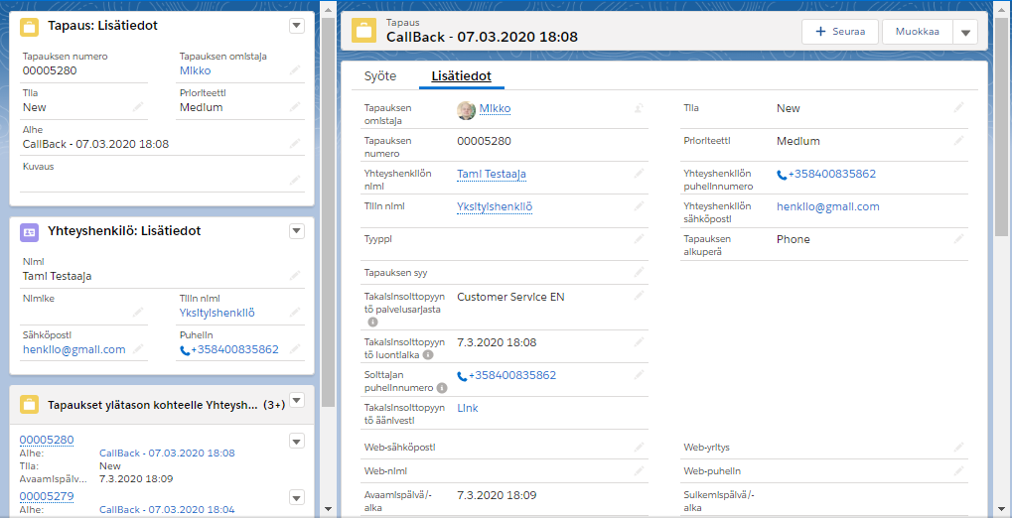
Example of CallBack Task from not identified contact:
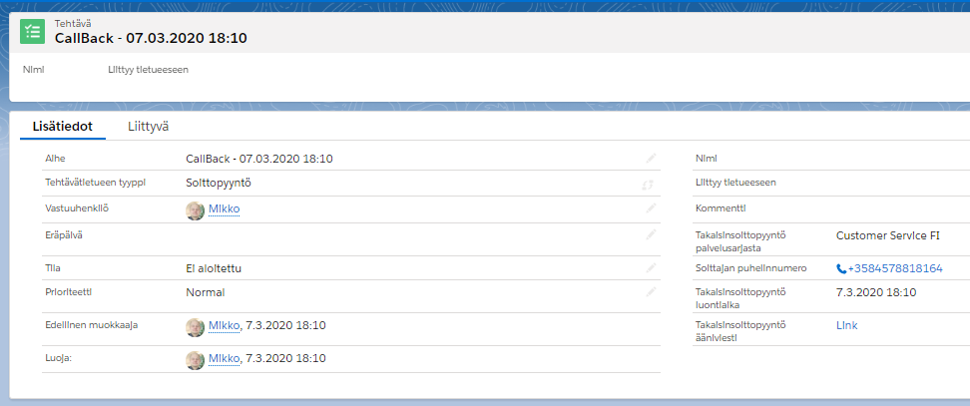

Dynamic Smart Routing based on any Salesforce data
Smart Routing functionality enables customer to dynamically route incoming phone calls based on Salesforce data. This is not especially affecting end user functionality, but enables intelligent routing decisions for incoming phone calls e.g. pass language IVR if we we know contact’s preferred language, prioritize caller in a voice queue based on their SLA level or route phone call to the agent who is owner of the most recent case for the contact, etc.
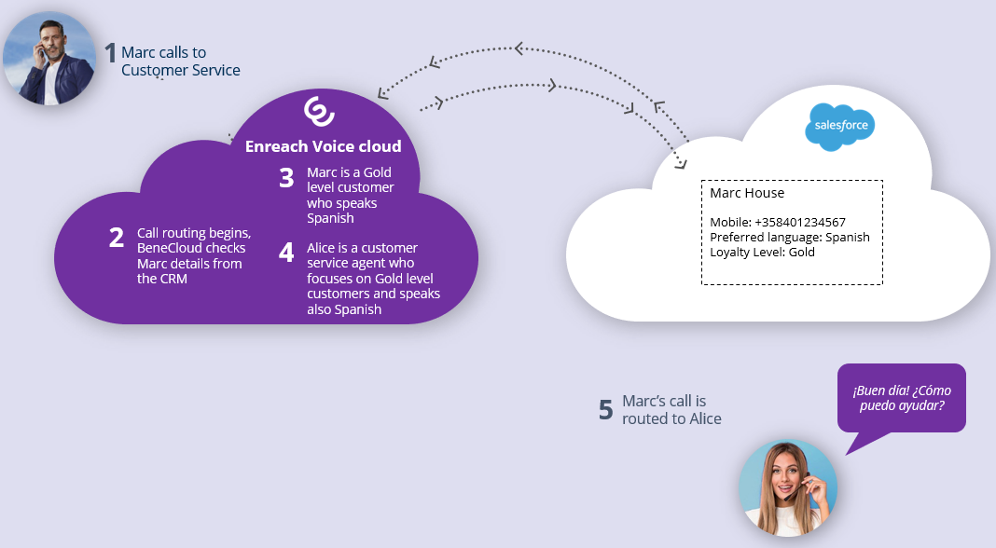
Smart Routing is typically activated on voice queues level and requires activation also at Enreach cloud configuration side. Enreach provides detailed implementation steps in a separate Smart Routing for Salesforce configuration document.
Native Salesforce Flows and Flow Builder is used to configure actual routing logic. Managed package includes two predefined Flow templates, which can be used and modified for specific customer scenario, when activating Smart Routing. Customer can freely create their own Scenario flows too.
Please consult Enreach for more details on the dynamic smart routing.

Enterprise Calls
Enables call activity creation in Salesforce for Enreach cloud phone calls, which were not already done and created by Salesforce embedded softphone and phone workflows. Main use case is customer calls answered/made in another Enreach cloud voice endpoint e.g. Mobile and Voice for Teams phone calls.
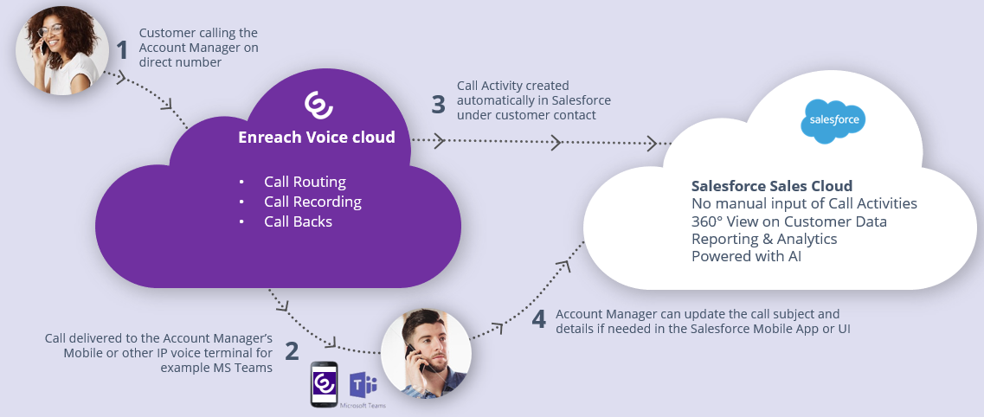
Enterprise Calls task activity creation happens automatically and doesn’t require any actions from end users and is not activated on end user basis.
Instead, admin controls and activates if and how calls lookup is activated. Call task activities creation via calls lookup module has the following requirements
- Phone call must by marked as ‘work call’ in Enreach cloud side
- Customer phone number must have at least a one contact record match in Salesforce
Admin can activate the functionality using continuous lookup mode, when call task activities are automatically created soon after the customer phone call is ended. Additionally admin may use one time look up mode, which allows do the look up and call task activity creation up to 7 days old customer phone calls.
Admin controls if call details are created as call task or case object. Also default status of the created record is configurable. If customer phone number is matched with single contact record, the created record is automatically linked to this contact.
Call task / case owner is automatically identified based on Enreach cloud user id. Requirement for this is that the user is also activated for Voice for Salesforce including External User ID mapping in the user configuration. Admin can configure default Salesforce user account, which is used as the owner when the above method is not available.

Enreach cloud management – general use cases

Voice service pool management
Voice queue management can be handled flexible from different endpoints.
Management capabilities require Enreach cloud Group Manager / Supervisor rights.
- Voice Center web UI
https://discover.benedesk.com
- Voice for iOS ja Android mobile app
https://play.google.com/store/apps/details?id=com.benemen.beneapp&hl=en
https://apps.apple.com/fi/app/beneapp/id989797121?l=en

Voice Center Web UI
- Login to https://discover.benedesk.com -> Service Pool Management
Service Pool Management view gives realtime snapshot of voice queues available for given agents and admins.
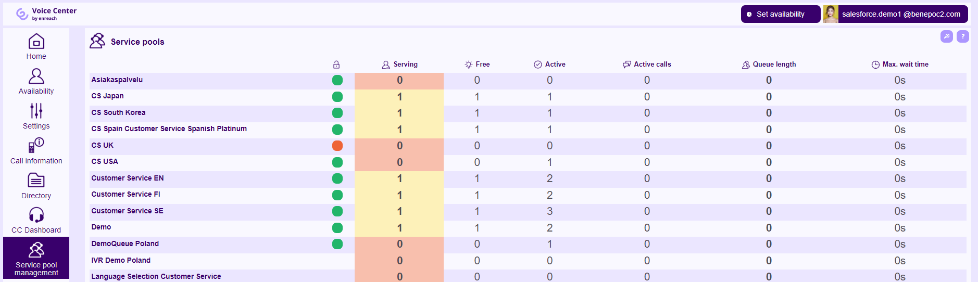
- Click any queue you would like to see in more detail and do changes in real time.
  - Modify directly on this screen existing Agent details. Like activate in the queue, change skill level.
  - Use “Users” option to remove & add users in the queue
  - Use “Settings” to modify voice queue workflow.
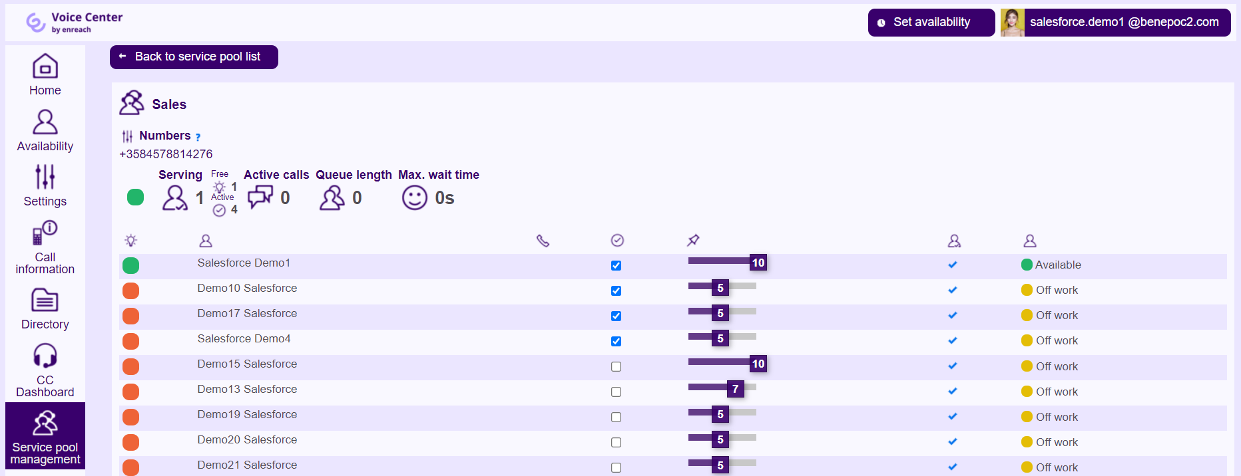
- Settings view is used to manage and modify voice queue workflow
  - Modify queue announcements, transfers where the calls are connected with given option, schedules when queue is open / closed and exceptions
  - Supervisor can upload new announcements to the system via “Create new prompt” option
  - “Details” show more detailed information on the configured workflow. These are done and modified via Enreach support request

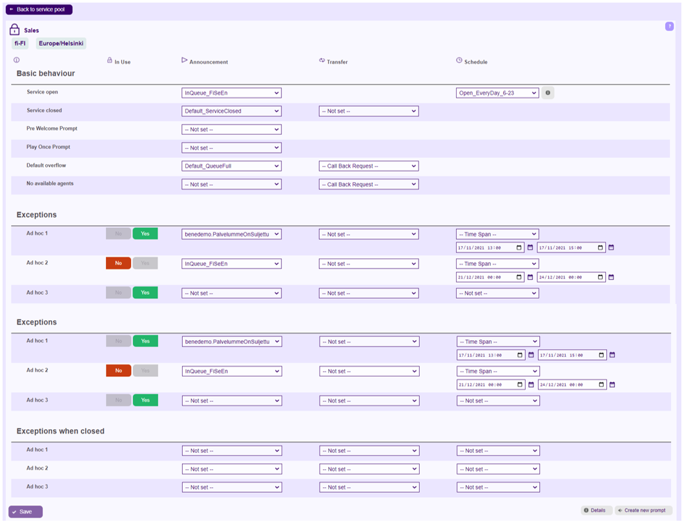

Voice for iOS and Android mobile app
Voice for iOS and Android provides easy to use and feature rich Enreach cloud voice channel management in Android and iOS smart phones. In addition to managing service pool voice queues, admin user may also set and control voice queue alarms and notification via mobile app. Possible notifiations are delivered as push notification to the mobile device.
Voice for iOS and Android brings many benefits for end users too. For example user can handle availability by coupld of clicks, go available/offwork for voice channel and if needed handle service phone calls via mobile.
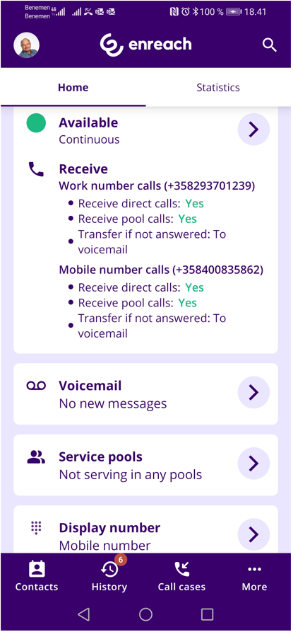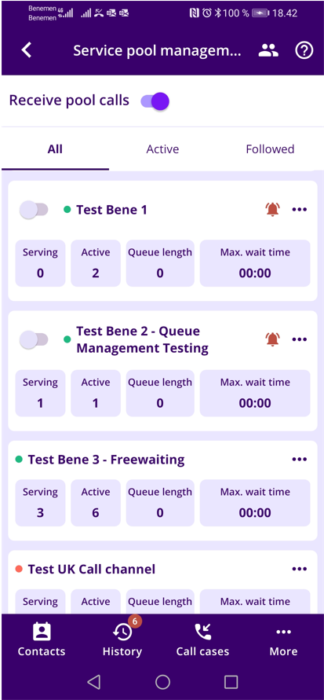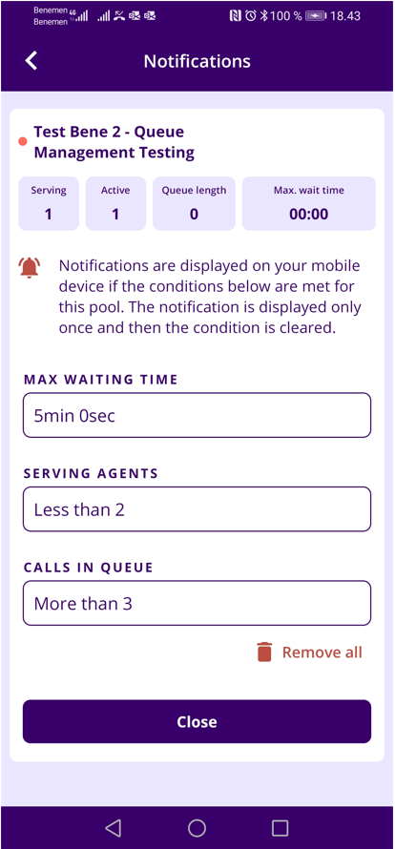

Dashboards and Reporting

Real-time monitoring dashboard
- Service pool voice queue real-time monitoring dashboard is available via Voice Center web UI https://discover.benedesk.com -> Service Pool Management.
Selecting any queue will open more detailed view of the queue.
- Additonally Service calls tab can be used to see in more detail ongoing and recent service calls.
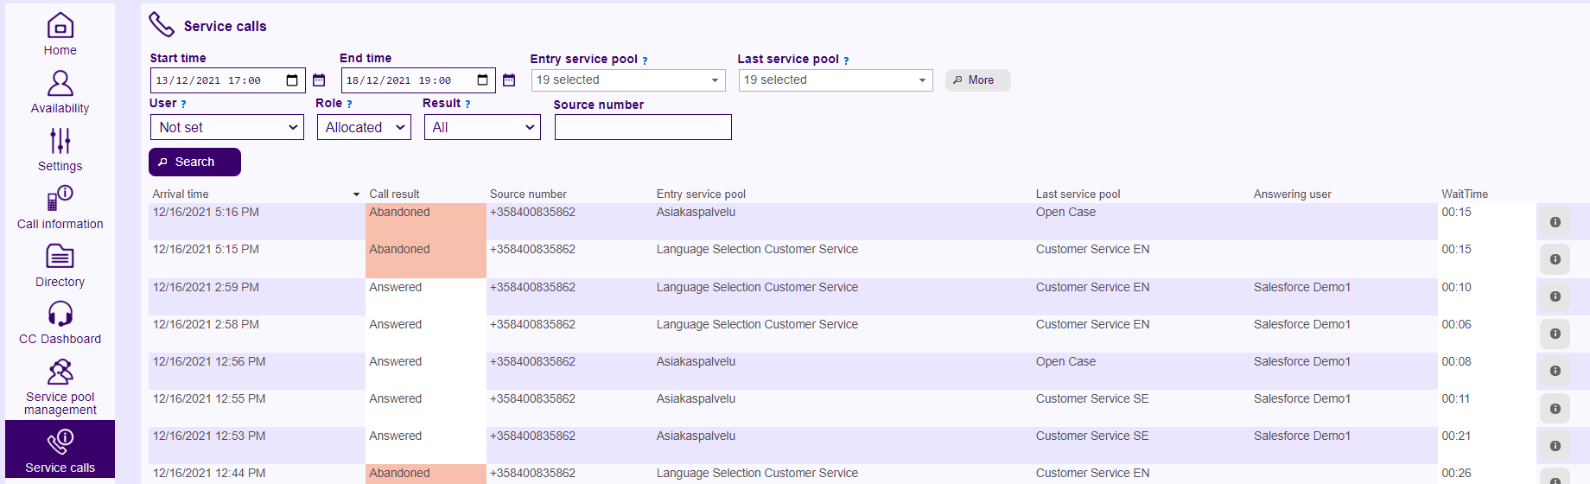
- More advanced real-time dashboards & info monitor views can be provided via Voice Analytics and/or Voice Monitor web reporting services and tools, if given service modules are purchased and configured for the customer. When configured, these online tools can be accessed via Voice Center web ui.
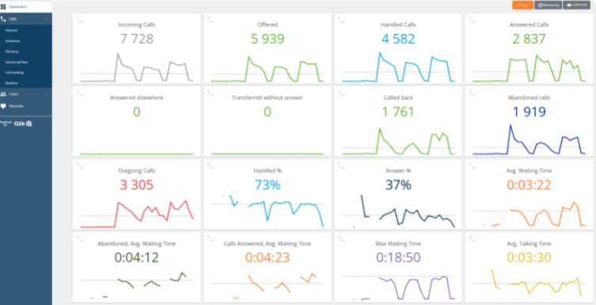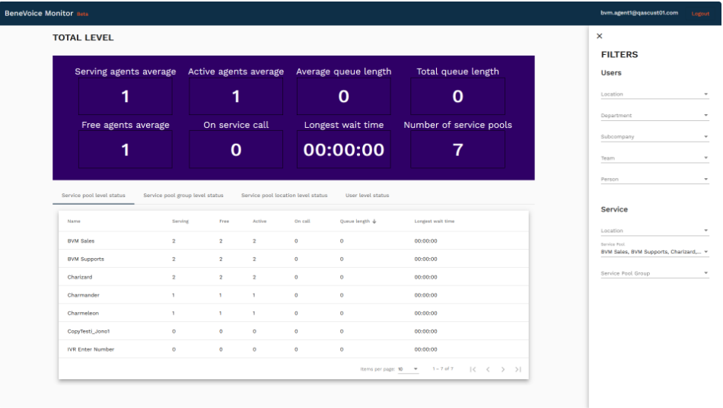

Saleforce Omni Supervisor
If Salesforce Omni-channel is in use, Omni Supervisor is the main tool monitoring agent work, salesforce omni queues and agent availability. Assuming Omni-Channel availability integration is enabled, dashboard includes availability reporting for voice channel.
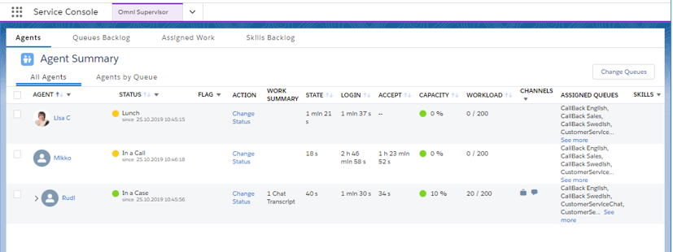

Reporting
Rich reporting capabilities can be provided via Voice Analytics online reporting service and Salesforce reporting & dashboards modules

Voice Analytics online reporting service
Provides detailed direct phone call, service call and call center reporting. When purchased and configured for the customer, web based reporting tool is accessed via Voice Center web UI by users / admins with reporting manager rights.
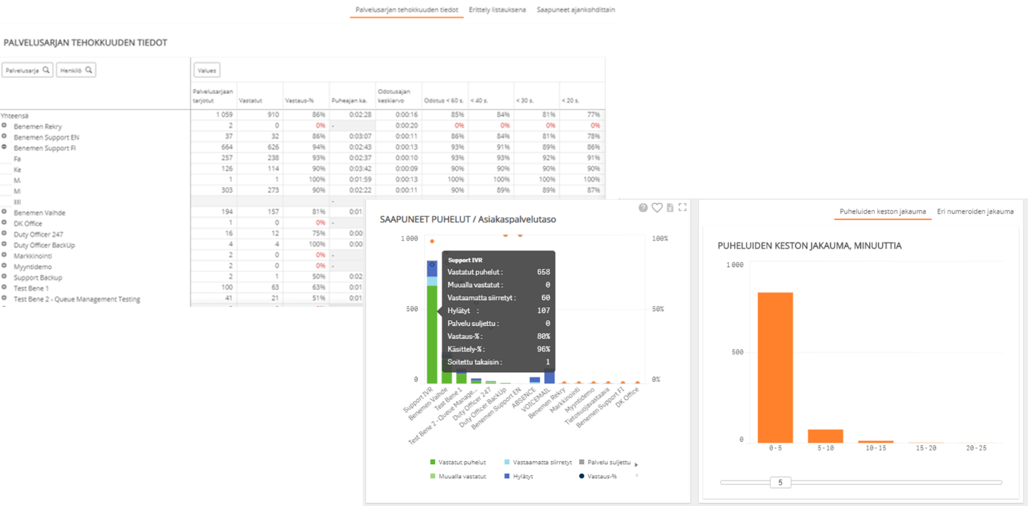

Salesforce Reports & Dashboards
Provides detailed reports for all the agent work and activities done via Salesforce. All the saved call tasks activities, call details and phone originated case data are available for Salesforce report creation. Additionally with Omni-Channel availability integration user presence reports will include agent availability reporting for voice channel too.
